CFG Project

# Business details for Website creation

## Company Name

Beneath the Fog

## Business owners

Brenda Brown and Pamela Crewe-Harris (sisters)

## Location

* Not available in store
* Pop up to local markets
* Sandyville-Hermitage, Newfoundland and Labrador

## Contact details

[beneaththefog13@gmail.com](mailto:beneaththefog13@gmail.com)

<https://www.facebook.com/profile.php?id=100078494063621> (just realised they didn’t choose their URL name so it’s just a random mix of numbers and letters. Will discuss changing this with them so it reflects their brand name & see if they will lose much from changing it now vs later).

## Target audience

* Mainly aged 28 to 43.
* Currently only targeting central and southern Newfoundland.
* A few select products for kids & hoping to make a dog shampoo in the near future).

## Competitors

* Salt Water Bath Bombs [www.swbb.ca](http://www.swbb.ca) 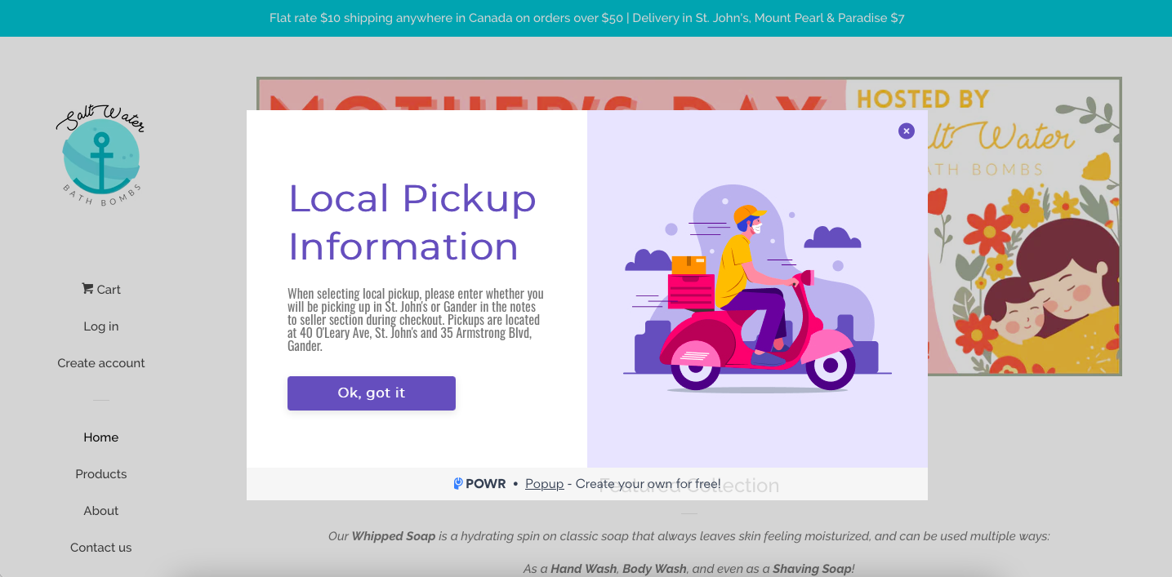
* Newfoundland Salt Company [www.newfoundlandsaltcompany.com](http://www.newfoundlandsaltcompany.com) 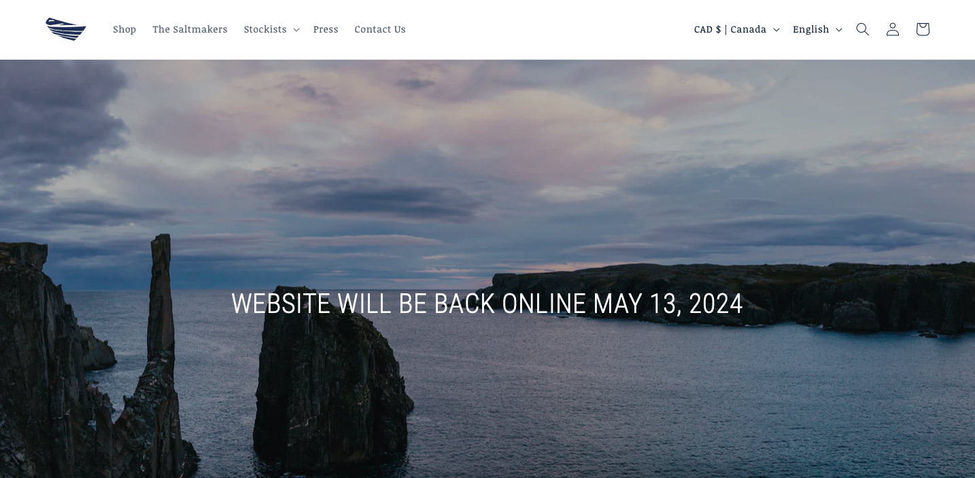
* East Coast Glow [www.eastcoastglow.ca](http://www.eastcoastglow.ca) 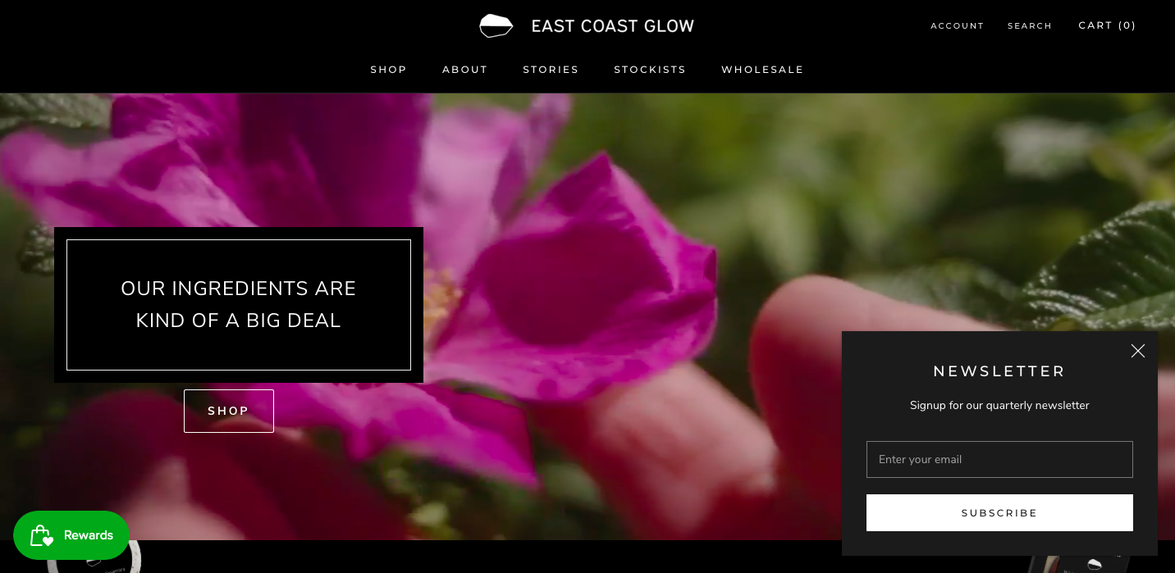

## Goal

To make products that are free of harsh chemicals

## About

## 

## Logo

Font: Arial

Picture of 2 birds to represent 2 sisters (Brenda and Pam)

Logo requested.

## Colour Scheme

Natural/nature. Earth tones. Key elements of the province: fog, ocean, seaside.

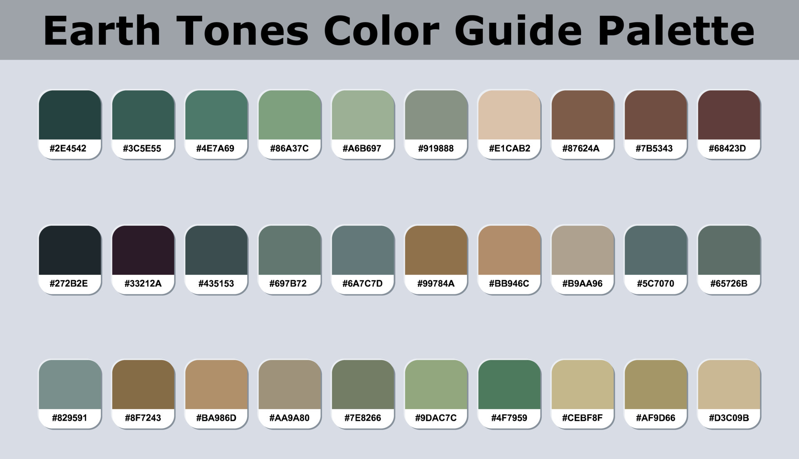

* Some products (eg. eye mask/makeup wipes) feature the Newfoundland tartan:

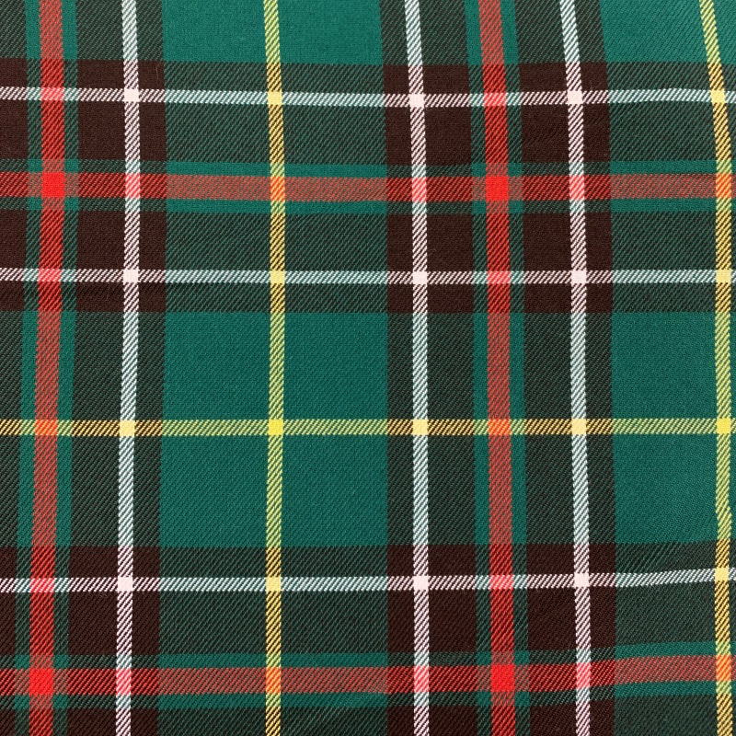

## Would like on their website

* Homepage
* Abous Us
* Products

## Function of website

Ideally, to have customers purchase products online directly from their website. However, if not possible yet, they would be happy to have a gallery style website showcasing products & information, where customers can contact them if interested in purchasing.

## Products available

### See facebook for images of products with description (includes prices)

* Bath bombs *main product*
* Eye masks (For sleeping)
* Reusable makeup removers
* Lip balms
* Hand and foot soaps
* Toilet bowl fizzies

## New initiatives/plans

* Packages for bridesmaids from bride
* Other pampering packages/deals
* Dog shampoo